
Name: Janushiya P A
Reg No: 1924260368
Course Code: CSA0224
Course Name: C Programming

TASK 3 – DEFINE THE CONSTANTS

Bloom’s Level: K3 – Apply

1. Aim
To define electricity tariff rates and billing limits as constants so that tariff revisions can be made easily in one place.
2. Algorithm
- Start.
- Define the tariff slab limits, rates, and fixed charge using #define.
- Read the electricity units consumed.
- Initialize the bill with the fixed charge of ₹50.
- Calculate the charge for units above 200 using RATE3_PAISE.
- Calculate the charge for units between 101 and 200 using RATE2_PAISE.
- Calculate the charge for the first 100 units using RATE1_PAISE.
- Add the slab charges to the fixed charge.
- Convert the total paise into rupees and paise and display the bill.
- Repeat for all test inputs.
- Stop.

3. Code

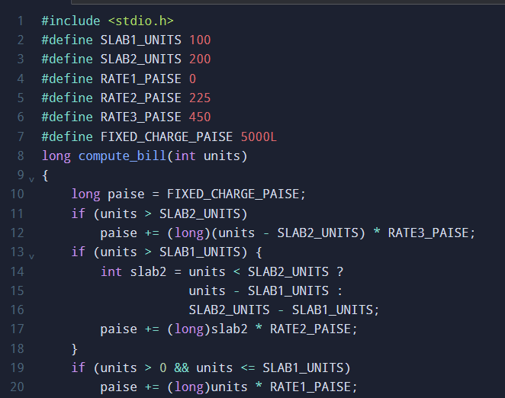

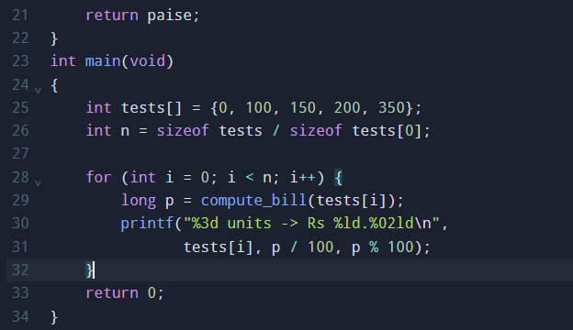

4. Output

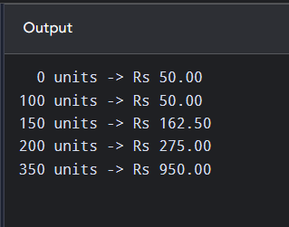

5. Result
The tariff rates and fixed charge were defined as constants, and the electricity bill was calculated according to the slab system. Updating a single tariff constant allows the revised rate to be applied consistently throughout the program.

